**DAILY ONLINE ACTIVITIES SUMMARY**

|  |  |  |  |  |  |  |  |
| --- | --- | --- | --- | --- | --- | --- | --- |
| **Date:** | **05/07/2020** | | | | **Name:** | **Churashma** | |
| **Sem & Sec** | **4th SEM 'A' Section** | | | | **USN:** | **4AL18CS019** | |
| **Online Test Summary** | | | | | | | |
| **Subject** | | **No test** | | | | | |
| **Max. Marks** | | **-** | | **Score** | | **-** | |
| **Certification Course Summary** | | | | | | | |
| **Course** | **Blockchain basics** | | | | | | |
| **Certificate Provider** | | | **greatlearning academy** | **Duration** | | | **2.5 hours** |
| **Coding Challenges** | | | | | | | |
| **Problem statement 1: Write a java program to find common elements between the two given arrays.** | | | | | | | |
| **Status: completed** | | | | | | | |
| **Uploaded the report in Github** | | | | **yes** | | | |
| **If yes Repository name** | | | | **https://github.com/Churashma/Lockdown-coding** | | | |
| **Uploaded the report in slack** | | | | **yes** | | | |

ONLINE TEST DETAILS: No test

CERTIFICATION COURSE DETAILS: Today I studied about accounts, blocks, transaction and Merkle trees.A hash tree, or the Merkle tree, encodes the blockchain data in an efficient and secure manner.Since there are numerous transactions stored on a particular block, all the transaction hashes in the block are also hashed, which results in a Merkle root.

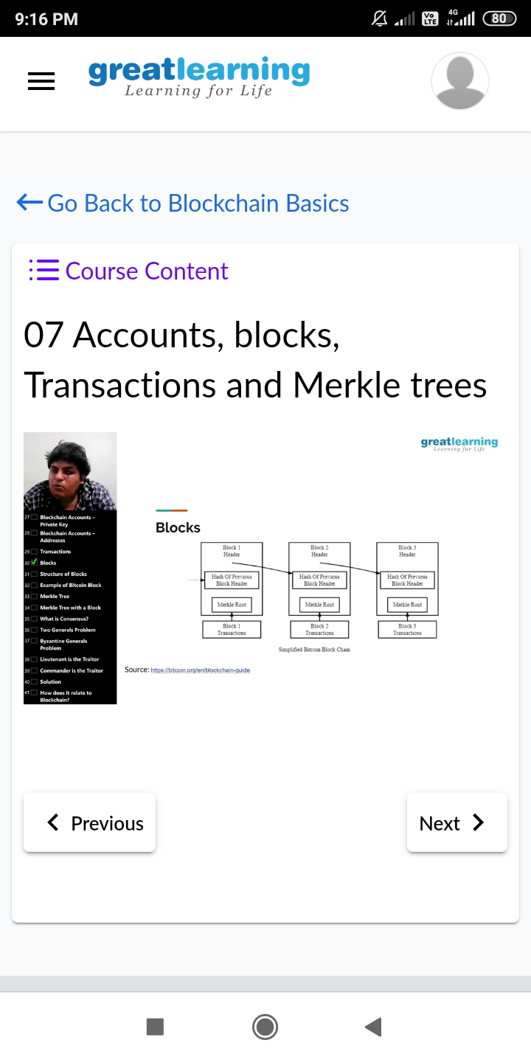

**CODING CHALLENGES DETAILS**:

Problem statement 1: Write a java program to find common elements between the two given arrays.

